|  |  |  |  |
| --- | --- | --- | --- |
| 99 | | 268,192.0000000001 | |
| NUMERO DE FRONTERAS | | ENERGIA AGREGADA | |
|  | | | |
| NO | | 0 | |
| CONTRATO | | VENCIMIENTO CONTRATO | |
|  | | | |
| 490,716,542 | 195 | | 16,737,768 |
| INGRESO 2019 | DÍAS CERTIFICADOS 2019 | | ENERGIA RESPALDADA 2019 |
|  | | | |
| 621,372,448 | 267 | | 23,222,200 |
| INGRESO 2020 | DÍAS CERTIFICADOS 2020 | | ENERGIA RESPALDADA 2020 |
|  | | | |
| 668,014,055 | 200 | | 28,803,346 |
| INGRESO 2021 | DÍAS CERTIFICADOS 2021 | | ENERGIA RESPALDADA 2021 |

|  |
| --- |
| **GRUPO EXITO**  USUARIO |

|  |
| --- |
| **Camilo Bermudez**  Ejecutivo de cuenta |

|  |
| --- |
| **Laura Cristina Zapata / Analista de Energía y Servicios Públicos / lczapata@grupo-exito.com**  PUNTO FOCAL |

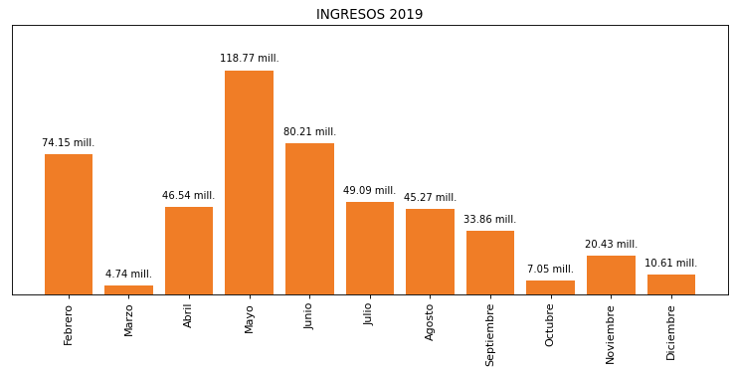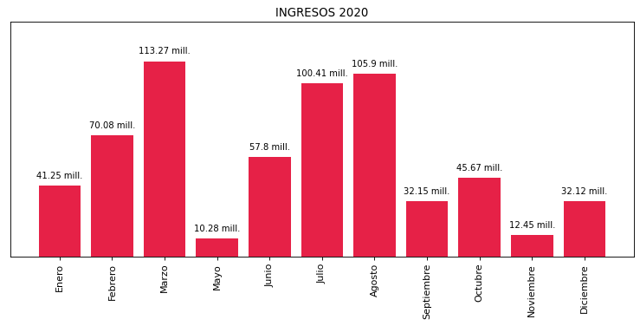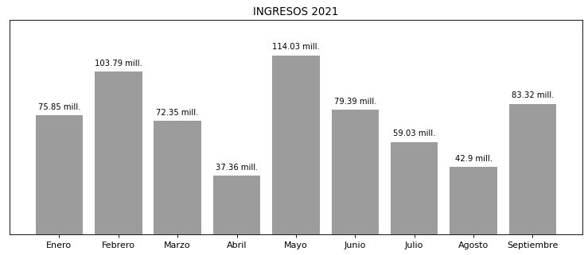

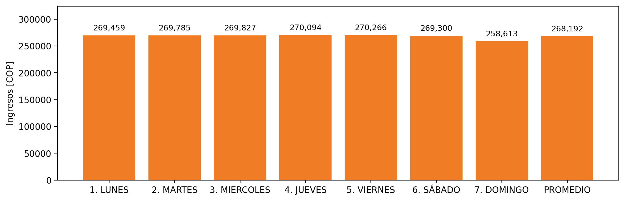

|  |  |  |  |  |  |  |  |  |  |  |
| --- | --- | --- | --- | --- | --- | --- | --- | --- | --- | --- |
| **FRONTERA** | **COD SIC** | **PREDIO** | **FRT DDV** | **TIPO DDV** | **PROMEDIO** | **PRÓXIMA ACTUALIZACIÓN** | **MARGEN DE ERROR** | **ÚLTIMA PRUEBA DDV** | **DÍAS PARTICIPACIÓN** | **FECHA REFERENCIA PRÓXIMA PRUEBA DDV** |
| ALMACENES EXITO S.A. - CEDI DEL CARIBE | Frt13973 | Prd01053 | Frt31250 | LBC | 16,207 | 2022-03-04 | 3,51 | 2021-08-16 | 26 | 2022-01-10 |
| ALMACENES EXITO S.A. - CEDI LAS VEGAS | Frt06369 | Prd01079 | Frt31297 | LBC | 16,207 | 2021-11-26 | 3,04 | 2020-12-22 | 90 | 2021-12-04 |
| ALMACENES EXITO S.A. - BUCARAMANGA | Frt04106 | Prd01054 | Frt31251 | LBC | 16,207 | 2022-02-16 | 3,16 | 2021-08-07 | 28 | 2022-01-04 |
| ALMACENES EXITO S.A. - LA FLORA | Frt00905 | Prd01082 | Frt31300 | LBC | 16,207 | 2022-03-04 | 2,88 | 2021-07-30 | 37 | 2021-12-24 |
| ALMACENES EXITO S.A. - VIVERO BUENAVISTA | Frt03648 | Prd01059 | Frt31270 | LBC | 16,207 | 2022-03-02 | 2,58 | 2021-09-23 | 0 | 2022-02-09 |
| ALMACENES EXITO S.A. - EXITO COLOMBIA | Frt00704 | Prd01083 | Frt31301 | LBC | 16,207 | 2021-11-25 | 2,22 | 2021-10-21 | 0 | 2022-02-28 |
| ALMACENES EXITO S.A. - SAN FERNANDO | Frt11069 | Prd01080 | Frt31298 | LBC | 16,207 | 2021-11-26 | 4,08 | 2021-09-06 | 15 | 2022-02-01 |
| ALMACENES EXITO S.A. - UNICENTRO CALI | Frt00777 | Prd01085 | Frt32881 | LBC | 16,207 | 2022-03-02 | 3,62 | 2021-08-09 | 27 | 2022-01-09 |
| ALMACENES EXITO S.A. - CASTELLANA | Frt01088 | Prd01066 | Frt31277 | LBC | 16,207 | 2021-11-23 | 2,31 | 2021-11-04 | 0 | 2022-03-04 |
| ALMACENES ÉXITO S.A - BELLO | Frt03666 | Prd01084 | Frt31302 | LBC | 16,207 | 2022-02-26 | 2,52 | 2021-10-19 | 0 | 2022-02-28 |
| ALMACENES EXITO S.A. - PEREIRA | Frt05997 | Prd01064 | Frt31275 | LBC | 16,207 | 2022-03-04 | 4,46 | 2021-09-16 | 2 | 2022-02-10 |
| ALMACENES EXITO S.A. - VIVERO (ALTOS DEL COUNTRY) | Frt01089 | Prd01062 | Frt31273 | LBC | 16,207 | 2022-02-26 | 8,39 | 2021-11-02 | 0 | 2022-03-04 |
| ALMACENES EXITO S.A. - VIVERO VALLEDUPAR | Frt01093 | Prd01057 | Frt31268 | LBC | 16,207 | 2022-02-10 | 3,51 | 2021-10-03 | 0 | 2022-02-20 |
| ALMACENES EXITO S.A. - BARRANQUILLA METROPOLITANO SUR | Frt06830 | Prd01074 | Frt31288 | LBC | 16,207 | 2021-12-16 | 6,54 | 2021-06-06 | 25 | 2022-01-14 |
| ALMACENES EXITO S.A. - VIVERO SANFRANCISCO | Frt00880 | Prd01065 | Frt31276 | LBC | 16,207 | 2022-02-26 | 4,29 | 2021-11-02 | 0 | 2022-03-04 |
| ALMACENES EXITO S.A | Frt28811 | Prd02041 | Frt37988 | LBC | 16,207 | 2022-02-25 | 2,83 | 2021-09-20 | 0 | 2022-02-16 |
| ALMACENES EXITO S.A. - SAN DIEGO CARTAGENA | Frt00818 | Prd01087 | Frt31305 | LBC | 16,207 | 2021-12-16 | 2,61 | 2021-09-20 | 0 | 2022-02-14 |
| ALMACENES EXITO S.A. - VECINO DEL ESTE | Frt09436 | Prd01096 | Frt31314 | LBC | 16,207 | 2022-02-26 | 2,21 | 2021-11-16 | 0 | 2022-03-04 |
| ALMACENES EXITO S.A. - UNICENTRO | Frt00778 | Prd01093 | Frt31311 | LBC | 16,207 | 2022-02-26 | 3,17 | 2021-07-22 | 42 | 2021-12-30 |
| ALMACENES EXITO S.A - CEDI PERECEDEROS CALIMA | Frt01030 | Prd01140 | Frt31620 | LBC | 16,207 | 2022-03-02 | 3,7 | 2021-09-07 | 13 | 2022-02-04 |
| ALMACENES EXITO S.A. - VECINO MONTERIA NORTE | Frt02142 | Prd02070 | Frt38320 | LBC | 16,207 | 2021-11-24 | 3,07 | 2021-11-04 | 0 | 2022-03-04 |
| ALMACENES EXITO S.A. - APARTADO | Frt06193 | Prd01091 | Frt31309 | LBC | 16,207 | 2022-02-16 | 3,84 | 2021-07-30 | 36 | 2021-12-29 |
| ALMACENES EXITO S.A. - CAUCASIA | Frt07578 | Prd01105 | Frt31437 | LBC | 16,207 | 2022-03-04 | 3,33 | 2021-07-27 | 39 | 2022-01-03 |
| ALMACENES EXITO S.A. - MAYORCA | Frt26928 | Prd01100 | Frt31379 | LBC | 16,207 | 2022-03-04 | 1,43 | 2021-07-20 | 49 | 2021-12-14 |
| ALMACENES EXITO S.A. - LA 33 MEDELLIN | Frt00775 | Prd01104 | Frt31436 | LBC | 16,207 | 2021-11-23 | 2,51 | 2021-10-19 | 0 | 2022-02-28 |
| ALMACENES EXITO S.A. - CITY PLAZA | Frt14066 | Prd01108 | Frt31440 | LBC | 16,207 | 2021-11-23 | 2,57 | 2021-09-06 | 12 | 2022-02-01 |
| ALMACENES EXITO S.A. - SABANETA | Frt07158 | Prd01101 | Frt31380 | LBC | 16,207 | 2021-11-23 | 1,54 | 2021-10-22 | 0 | 2022-03-04 |
| ALMACENES EXITO S.A. - CARULLA SANTA LUCIA | Frt10991 | Prd02074 | Frt38324 | LBC | 16,207 | 2021-11-24 | 4,44 | 2021-10-10 | 0 | 2022-02-18 |
| ALMACENES EXITO S.A. - CARULLA VILLA SUSANA | Frt10990 | Prd02075 | Frt38325 | LBC | 16,207 | 2021-11-25 | 2,74 | 2021-09-21 | 0 | 2022-02-17 |
| ALMACENES EXITO S.A._ CARULLA SAN LUCAS | Frt02004 | Prd01113 | Frt31445 | LBC | 16,207 | 2021-11-23 | 1,75 | 2021-10-20 | 0 | 2022-02-27 |
| ALMACENES EXITO S.A. - RIONEGRO | Frt06738 | Prd01103 | Frt31382 | LBC | 16,207 | 2021-11-23 | 1,82 | 2021-11-18 | 0 | 2022-03-03 |
| ALMACENES EXITO S.A - ENVIGADO CENTRO | Frt02002 | Prd01109 | Frt31441 | LBC | 16,207 | 2022-02-26 | 1,81 | 2021-09-07 | 13 | 2022-02-01 |
| ALMACENES EXITO S.A. - ARMENIA UNICENTRO | Frt24858 | Prd01482 | Frt34863 | LBC | 16,207 | 2022-03-05 | 4,01 | 2021-09-14 | 7 | 2022-02-07 |
| ALMACENES EXITO S.A. - CARULLA OVIEDO | Frt04342 | Prd01107 | Frt31439 | LBC | 16,207 | 2022-03-04 | 2,89 | 2021-11-17 | 0 | 2022-03-03 |
| ALMACENES EXITO S.A. - EXITO SIMON BOLIVAR - CALI | Frt21281 | Prd01088 | Frt31306 | LBC | 16,207 | 2022-03-04 | 15,43 | 2021-01-18 | 88 | 2021-12-04 |
| ALMACENES EXITO S.A. - SUPER INTER LA TIENDA | Frt12152 | Prd01985 | Frt37753 | LBC | 16,207 | 2022-01-31 | 2,09 | 2021-09-18 | 2 | 2022-02-13 |
| ALMACENES EXITO S.A. - EXITO TURBO | Frt21005 | Prd01112 | Frt31444 | LBC | 16,207 | 2022-02-18 | 1,9 | 2021-02-17 | 89 | 2021-12-05 |
| ALMACENES EXITO S.A. - CARULLA VIVERO LLANO GRANDE | Frt07700 | Prd01123 | Frt31455 | LBC | 16,207 | 2022-02-26 | 4,19 | 2021-09-09 | 8 | 2022-02-03 |
| ALMACENES EXITO S.A. - EXITO CRISTAL ARMENIA | Frt20927 | Prd01986 | Frt37754 | LBC | 16,207 | 2022-01-31 | 2,1 | 2021-09-14 | 7 | 2022-02-07 |
| ALMACENES EXITO S.A. - CAREPA | Frt42173 | Prd02269 | Frt42173 | LBC | 16,207 | 2022-02-22 | 2,43 | 2021-07-30 | 38 | 2022-01-08 |
| ALMECENES EXITO S.A | Frt02000 | Prd01115 | Frt31447 | LBC | 16,207 | 2022-01-28 | 2,32 | 2020-12-09 | 88 | 2021-12-04 |
| ALMACENES EXITO S.A. - GUADALUPE | Frt20163 | Prd01473 | Frt34852 | LBC | 16,207 | 2022-02-26 | 2,11 | 2020-12-02 | 88 | 2021-12-05 |
| ALMACENES EXITO S.A. - GRAN VIA | Frt06926 | Prd01117 | Frt31449 | LBC | 16,207 | 2021-11-25 | 4,18 | 2021-10-21 | 0 | 2022-02-28 |
| ALMACENES EXITO S.A. | Frt07510 | Prd01111 | Frt31443 | LBC | 16,207 | 2021-11-23 | 3,1 | 2021-10-20 | 0 | 2022-02-28 |
| ALMACENES EXITO S.A. - BELEN | Frt26591 | Prd01120 | Frt31452 | LBC | 16,207 | 2022-02-26 | 2,99 | 2021-07-22 | 40 | 2022-01-01 |
| ALMACENES ÉXITO S.A.- LOS MOLINOS | Frt06450 | Prd01116 | Frt31448 | LBC | 16,207 | 2022-03-01 | 3,14 | 2021-10-19 | 0 | 2022-02-28 |
| ALMACENES EXITO S.A. - CARULLA POBLADO | Frt02003 | Prd01124 | Frt31461 | LBC | 16,207 | 2021-11-23 | 1,83 | 2021-09-13 | 6 | 2022-02-11 |
| ALMACENES EXITO S.A. - CADENALCO S.A. (LEY DE BELLO) | Frt02005 | Prd01122 | Frt31454 | LBC | 16,207 | 2021-11-25 | 2,35 | 2021-10-22 | 0 | 2022-03-03 |
| ALMACENES EXITO S.A. - SUPERINTER DOSQUEBRADAS | Frt06262 | Prd01424 | Frt34218 | LBC | 16,207 | 2022-03-08 | 3,38 | 2021-09-16 | 2 | 2022-02-13 |
| ALMACENES EXITO S.A. - CARULLA LAURELES | Frt06777 | Prd01118 | Frt31450 | LBC | 16,207 | 2021-11-23 | 3,45 | 2021-06-14 | 71 | 2021-12-05 |
| ALMACENES EXITO S.A_ CARULLA CERRITOS | Frt26495 | Prd01995 | Frt37763 | LBC | 16,207 | 2022-01-31 | 1,65 | 2021-09-18 | 2 | 2022-02-12 |
| ALMACENES EXITO S.A. - PALMETTO | Frt05763 | Prd01475 | Frt34854 | LBC | 16,207 | 2022-02-26 | 3,75 | 2021-03-25 | 89 | 2021-12-05 |
| ALMACENES EXITO S.A. - SUPERINTER PRIMAVERA | Frt26482 | Prd01433 | Frt34241 | LBC | 16,207 | 2022-02-26 | 2,91 | 2020-12-01 | 88 | 2021-12-05 |
| ALMACENES EXITO S.A. - CARULLA TRADE CENTER CALI | Frt01067 | Prd01425 | Frt34219 | LBC | 16,207 | 2022-02-26 | 1,89 | 2020-12-02 | 88 | 2021-12-05 |
| ALMACENES EXITO S.A. - SUPERINTER CARTAGO | Frt07462 | Prd01419 | Frt34064 | LBC | 16,207 | 2022-02-26 | 2,59 | 2021-09-13 | 7 | 2022-02-08 |
| ALMACENES EXITO S.A. - LEY SAN CANCIO | Frt01060 | Prd01991 | Frt37759 | LBC | 16,207 | 2021-11-24 | 1,72 | 2021-09-21 | 0 | 2022-02-14 |
| ALMACENES EXITO S.A. - CARULLA PINARES | Frt26927 | Prd01989 | Frt37757 | LBC | 16,207 | 2022-01-31 | 2,05 | 2021-09-17 | 2 | 2022-02-08 |
| ALMACENES EXITO S.A. - LEY LA 70 | Frt02066 | Prd01126 | Frt31500 | LBC | 16,207 | 2022-02-26 | 2,5 | 2021-09-10 | 9 | 2022-02-03 |
| ALMACENES EXITO S.A. - SAN MATEO | Frt03175 | Prd01061 | Frt31272 | LBC | 16,207 | 2021-11-24 | 1,63 | 2020-08-06 | 89 | 2021-12-04 |
| ALMACENES EXITO S.A. - CARULLA VIVERO PINAR | Frt04071 | Prd01127 | Frt31501 | LBC | 16,207 | 2022-02-26 | 2,06 | 2021-06-15 | 72 | 2021-12-05 |
| ALMACENES EXITO S.A. - CARULLA MANIZALEZ | Frt04943 | Prd01988 | Frt37756 | LBC | 16,207 | 2022-01-31 | 2,61 | 2020-12-02 | 88 | 2021-12-04 |
| ALAMACENES EXITO S.A. - SUPER INTER SILOE CALI | Frt01429 | Prd01480 | Frt34861 | LBC | 16,207 | 2022-03-08 | 3,43 | 2020-12-09 | 88 | 2021-12-05 |
| SUPERINTER PASARELA | Frt31242 | Prd01990 | Frt37758 | LBC | 16,207 | 2022-01-31 | 2,68 | 2021-03-17 | 89 | 2021-12-05 |
| ALMACENES EXITO S.A. - SUPER INTER ARMENIA LA 19 | Frt22162 | Prd01993 | Frt37761 | LBC | 16,207 | 2022-01-31 | 2,12 | 2021-09-15 | 7 | 2022-02-07 |
| ALMACENES EXITO S.A. - SUPERINTER GUAYACANES | Frt18580 | Prd01420 | Frt34065 | LBC | 16,207 | 2022-02-26 | 2,61 | 2021-03-16 | 89 | 2021-12-05 |
| ALMACENES EXITO S.A - PEREIRA CENTRO | Frt02069 | Prd01483 | Frt34864 | LBC | 16,207 | 2022-03-08 | 2,17 | 2021-09-17 | 2 | 2022-02-09 |
| ALMACENES EXITO S.A. - AV CENTENARIO | Frt22365 | Prd02042 | Frt37989 | LBC | 16,207 | 2021-11-24 | 3,19 | 2021-09-15 | 7 | 2022-02-03 |
| ALMACENES EXITO S.A. - VILLA COLOMBIA | Frt19741 | Prd01481 | Frt34862 | LBC | 16,207 | 2022-03-08 | 2,38 | 2020-12-21 | 88 | 2021-12-05 |
| ALMACENES EXITO S.A. - VIVA LAURELES | Frt21105 | Prd01271 | Frt32663 | LBC | 16,207 | 2021-11-25 | 3,22 | 2020-08-16 | 88 | 2021-12-05 |
| ALMACENES EXITO S.A-EXITO ARMENIA CENTRO | Frt31210 | Prd01992 | Frt37760 | LBC | 16,207 | 2021-11-24 | 2,76 | 2020-12-01 | 89 | 2021-12-05 |
| ALMACENES EXITO S.A. - SAN ANTONIO 2 | Frt00703 | Prd01270 | Frt32662 | LBC | 16,207 | 2021-11-23 | 6,15 | 2020-08-16 | 89 | 2021-12-04 |
| ALMACENES EXITO S.A. - CALLE 28 IBAGUE | Frt04210 | Prd01426 | Frt34228 | LBC | 16,207 | 2022-02-26 | 2,7 | 2019-08-26 | 89 | 2021-12-05 |
| SUPERINTER ACOPI | Frt30921 | Prd01987 | Frt37755 | LBC | 16,207 | 2021-11-24 | 1,77 | 2020-07-13 | 89 | 2021-12-04 |
| ALMACENES EXITO S.A. -SUPERINTER JAMUNDI | Frt07535 | Prd01478 | Frt34859 | LBC | 16,207 | 2022-03-08 | 3,07 | 2020-07-31 | 89 | 2021-12-05 |
| ALMACENES EXITO S.A. - CEDI MONTEVIDEO | Frt00774 | Prd01048 | Frt31214 | LBC | 16,207 | 2021-11-24 | 3,08 | 2018-10-01 | 0 | 2022-03-04 |
| ALMACENES EXITO S.A. - VILLA COUNTRY BQUILLA | Frt00779 | Prd02072 | Frt38322 | LBC | 16,207 | NO APLICA | NO APLICA | NO APLICA | 0 | 2022-03-04 |
| ALMACENES EXITO S.A. - NEIVA | Frt00953 | Prd01058 | Frt31269 | LBC | 16,207 | 2021-11-24 | 5,33 | 2018-10-01 | 0 | 2022-03-04 |
| ALMACENES EXITO S.A. - SINCELEJO | Frt01058 | Prd02071 | Frt38321 | LBC | 16,207 | 2021-11-24 | 2,28 | 2018-10-01 | 0 | 2022-03-04 |
| ALMACENES EXITO S.A. - ORIENTAL BUCARAMANGA | Frt01228 | Prd01072 | Frt31286 | LBC | 16,207 | 2021-11-24 | 2,76 | 2018-10-01 | 0 | 2022-03-04 |
| ALMACENES EXITO S.A. - CARULLA CALLE 82 | Frt01675 | Prd02076 | Frt38326 | LBC | 16,207 | 2021-11-24 | 2,23 | 2018-10-01 | 0 | 2022-03-04 |
| ALMACENES EXITO S.A. | Frt01850 | Prd01471 | Frt34795 | LBC | 16,207 | 2022-02-26 | 3,85 | 2018-10-01 | 0 | 2022-03-04 |
| ALMACENES EXITO S.A - PALMIRA | Frt01996 | Prd01434 | Frt34242 | LBC | 16,207 | 2022-03-08 | 8,9 | 2018-10-01 | 0 | 2022-03-04 |
| ALMACENES EXITO S.A. - CARULLA EL TESORO | Frt02007 | 0 | 0 | LBC | 16,207 | NO APLICA | NO APLICA | NO APLICA | 289 | 2022-03-04 |
| ALMACENES EXITO S.A - EXITO PASOANCHO | Frt02044 | Prd01474 | Frt34853 | LBC | 16,207 | 2022-02-26 | 7,04 | 2018-10-01 | 0 | 2022-03-04 |
| ALMACENES EXITO S.A. - CARULLA 86 | Frt02253 | Prd02073 | Frt38323 | LBC | 16,207 | 2021-11-24 | 4,03 | 2018-10-01 | 0 | 2022-03-04 |
| ALMACENES EXITO S.A. - BARRANQUILLA | Frt04906 | Prd01055 | Frt31252 | LBC | 16,207 | NO APLICA | NO APLICA | NO APLICA | 91 | 2022-03-04 |
| ALMACENES EXITO S.A. - VIVERO BUENAVISTA SANTA MARTA | Frt06032 | Prd01063 | Frt31274 | LBC | 16,207 | 2021-11-24 | 4,36 | 2018-10-01 | 0 | 2022-03-03 |
| ALMACENES EXITO S.A. - TULUA | Frt06317 | Prd02069 | Frt38319 | LBC | 16,207 | NO APLICA | NO APLICA | NO APLICA | 0 | 2022-03-04 |
| ALMACENES EXITO S.A. - CARULLA CIUDAD JARDIN | Frt06410 | Prd01477 | Frt34856 | LBC | 16,207 | 2022-03-01 | 2,69 | 2018-10-01 | 0 | 2022-03-04 |
| ALMACENES EXITO S.A. - UNIVILLAVO | Frt06788 | Prd01068 | Frt31279 | LBC | 16,207 | 2022-01-19 | 2,22 | 2018-10-01 | 0 | 2022-03-04 |
| ALMACENES EXITO S.A. - SINCELEJO | Frt07009 | Prd01069 | Frt31280 | GPE | 16,207 | 2022-02-17 | NO APLICA | 2021-05-10 | 52 | 2022-01-11 |
| ALMACENES EXITO S.A. - CARULLA VIVERO PANCE | Frt07151 | Prd01141 | Frt31621 | LBC | 16,207 | 2022-02-26 | 3,02 | 2018-10-01 | 0 | 2022-03-04 |
| EXITO S.A. - BUENAVENTURA | Frt07593 | Prd01983 | Frt37751 | LBC | 16,207 | 2021-11-25 | 1,94 | 2018-10-01 | 0 | 2022-03-04 |
| ALMACENES EXITO - CARULLA ALEJANDRIA (LA VISITACIÓN) | Frt07972 | Prd01114 | Frt31446 | LBC | 16,207 | NO APLICA | NO APLICA | NO APLICA | 180 | 2022-03-04 |
| ALMACENES EXITO S.A. - CARULLA CASTILLO GRANDE | Frt10006 | Prd01089 | Frt31307 | LBC | 16,207 | 2021-12-16 | 4,04 | 2018-10-01 | 0 | 2022-03-04 |
| ALMACENES EXITO S.A. - SUPERINTER LA COMETA | Frt10204 | Prd01476 | Frt34855 | LBC | 16,207 | 2022-03-01 | 1,73 | 2018-10-01 | 0 | 2022-03-04 |
| ALMACENES EXITO S.A. - SUPERINTER MELENDEZ | Frt11414 | Prd01444 | Frt34295 | LBC | 16,207 | 2022-02-26 | 2,25 | 2018-10-01 | 0 | 2022-03-04 |
| ALMACENES EXITO S.A_ - ENVIGADO 2 (CENTRO DE COMPUTO) | Frt18925 | 0 | 0 | LBC | 16,207 | NO APLICA | NO APLICA | NO APLICA | 289 | 2022-03-04 |
| SUPERINTER ACUARELA | Frt30922 | Prd01994 | Frt37762 | LBC | 16,207 | 2022-01-31 | 2,4 | 2018-10-01 | 0 | 2022-03-04 |